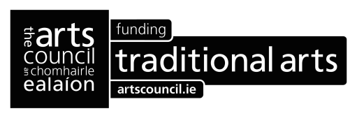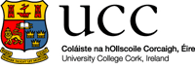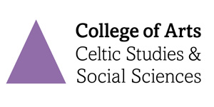
Traditional Artist in Residence
Closing Date for Applications: 5:30pm Thursday 9 November 2023
Department: Department of Music School: School of Film, Music and Theatre:
Contract Type: Fixed Term Part-Time.

TRADITIONAL ARTIST IN RESIDENCE AT UCC
The Arts Council and University College Cork invite applications from traditional artists of distinction for the role of Traditional Artist in Residence at UCC for the calendar year 2024.
The Traditional Artist in Residence, based in the Department of Music in the College of Arts, Celtic Studies, and Social Sciences, is designed to provide a traditional artist (traditional musician, singer, dancer, story-teller or practitioner of the oral arts such as agallamh beirte and lúibíní) with a unique opportunity to develop their practice in a university environment while offering students of music the opportunity to engage with a practising artist in a meaningful way during the course of their studies.
About the residency
The Traditional Artist in Residence will be engaged for the calendar year 2024 and will be situated in the Department of Music at UCC.
The residency will have two parts:
From January to June 2024, the Traditional Artist in Residence will be supported to engage with students and staff. This programme of engagement will be designed by the Traditional Artist in Residence, in consultation with Music Department staff, and could include focused postgraduate teaching, workshops, mentoring, public events or other activities that showcase the traditional arts across the wider UCC campus community. Contact time with students and staff during this time will be capped at four hours per week, and the Traditional Artist in Residence will not be expected to deliver core curriculum.
From July to December 2024, the Traditional Artist in Residence will be supported to concentrate wholly on their own practice.
The fee to the Traditional Artist in Residence is €30,000, with the Arts Council contributing €20,000 and the university €10,000. UCC will provide the Traditional Artist in Residence with a dedicated space, where they can conduct their own creative practice, within the university. UCC will also support the residency administratively. The fee will be paid in two instalments directly by the Arts Council, with a final report to be submitted by the Traditional Artist in Residence at the conclusion of the residency.

Making an Application
To make an application, artists should adhere to the following:

- The applicant should be a professional practising artist. Although they might not earn income continuously or exclusively from their arts practice, applicants must identify themselves, and be recognised by their peers, as professional practising artists.

- In line with the Public Sector Equality and Human Rights Duty, the Arts Council and UCC are committed to ensuring that they take positive policy measures to promote equality of opportunity for all those living in Ireland, regardless of their gender, sexual orientation, civil or family status, religion, age, disability, race or membership of the Traveller Community. Furthermore, we note the ground of socioeconomic background as a further basis for which equality of opportunity must be guaranteed. We therefore welcome applications that are representative of the diversity of Irish society, including but not limited to any of the characteristics outlined above.

- Applicants based outside Ireland must ensure that they have the necessary documentation to work in Ireland. The Arts Council or University College Cork cannot take responsibility for securing visas and/or work permits on an applicant’s behalf.

To make an application, artists must provide:
- A detailed proposal. This should outline the applicant’s vision for the role and a proposed approach for engaging with students, staff and the wider university. Relevant experience to support the proposal should be referenced.
- A one page artist’s statement, describing how the residency could impact on the development of the artist’s practice in the traditional arts.
- A detailed CV (maximum 3 pages).
Applications should be sent to JTalty@ucc.ie by 5.30 pm on Thursday, 9 November 2023. Applications will be accepted by email only. Applications received after the closing date will not be accepted.
Assessment Process
Upon receipt of applications, the Arts Council and UCC will establish a selection committee, comprising representatives from UCC, one from the Arts Council and an external panellist with traditional arts expertise. The selection committee will shortlist applicants based on the following criteria:
- artistic track record (in the traditional arts) of the applicant .
- quality of idea/approach (referred to above), as outlined in the application
- potential impact of the residency on the traditional artist’s own creative practice
A shortlist will be established (of no more than six applicants). Shortlisted applicants will be called to interview in late-November/December. The interview may be held via video conference call. It will allow the shortlisted applicants to discuss their vision, proposal and experience in more detail. The panel will make the final decision based on the above criteria.

